RENTAL PARTICULARS

BISHOP GARDEN TOWERS, FIRST NGONG AVENUE NAIROBI
_______________________________________________________________________
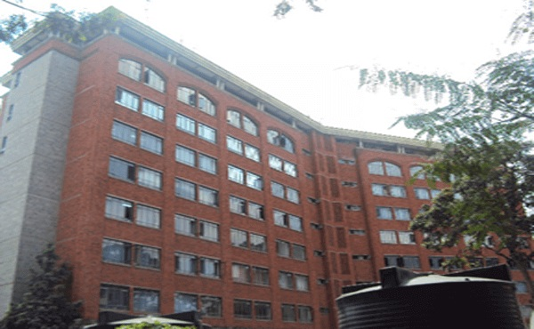

Location: Along First Ngong Avenue, Off Ngong road, Community Area Nairobi |  | Description: Office Block for rent
Availability: April 2019
Total Office Area:  78,027 sq. Ft | Available Spaces:  Ground Floor – 3,908 sq ft  1st Floor – 3,053 (three quarter floor)  6th Floor – 2,010 sq ft (full floor)  6th Floor – 2,010 sq ft (full floor) |  | Rent:  Offices: Kshs. 80 /- p.s.f p.m  Service Charge:  Kshs. 30/- p.s.f p.m  Parking:  Kshs. 6,000/- per bay per month
Lease Term: 6 Years |  |  | Annual Escalation: 15% Biennially
Commentary:
The building has a standby generator, adequate water storage facilities and ample water supply, telephone and computer cabling as well as main fiber optic network backbone. The building has a high speed lift with stops on each floor, security guarding, modern washrooms, kitchenette area among other amenities.

