RENTAL PARTICULARS

CROSSROAD MALL – FACT SHEET – SHOPS & OFFICE SUITES TO LET
KAREN SHOPPING CENTRE – NAIROBI

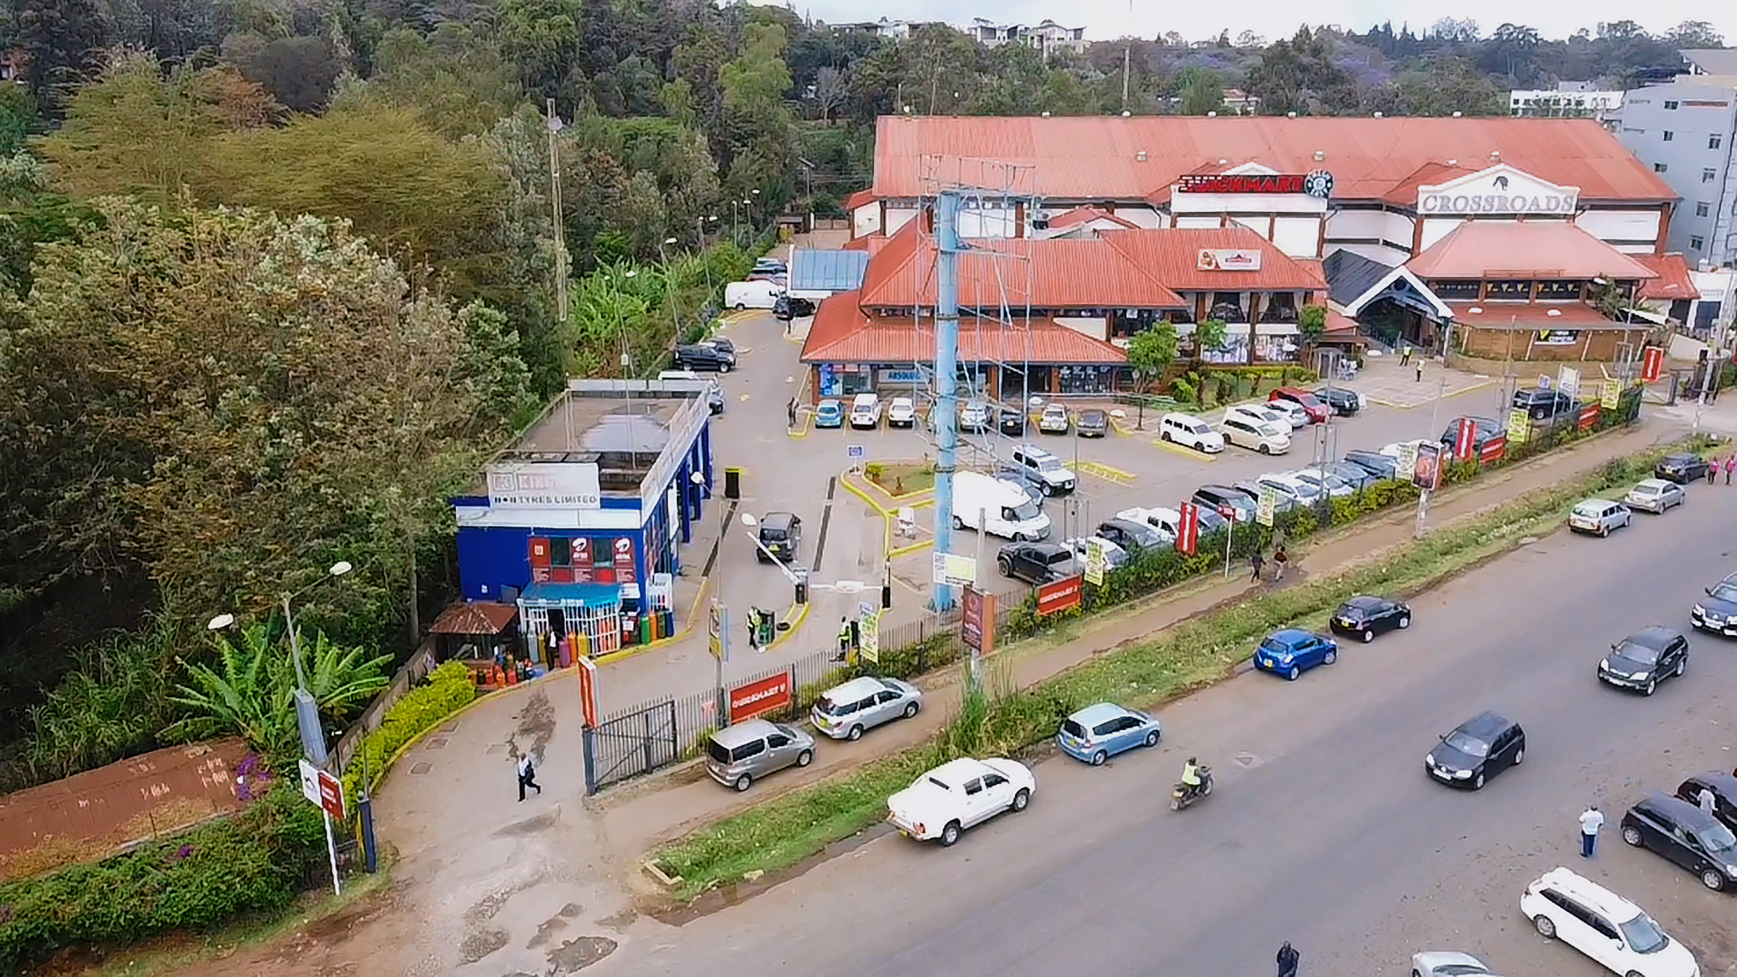
_______________________________________________________________________
Location: Located in Karen Shopping Centre Area, Nairobi |  | Description: 1 Storey Commercial Block To Let  Typical shops  Ground Floor – 31No. Shops  First Floor – 11No.Shops  Ground Floor - Parking level by KAPS (Customers)
Total Office Area:  56,396sq. Ft | Available Spaces:  Shops – From 162sq ft | Rent :  Ground Floor: Kshs.200/- p.s.f p.m  First Floor: Kshs.150/- p.s.f p.m
Total Office Area:  56,396sq. Ft | Available Spaces:  Shops – From 162sq ft | Service Charge: Kshs. 24/- p.s.fp.m  Parking Charge: Kshs. 6,000/- (Excluding VAT)
Lease Term: 6 Years |  | Biennial Escalation: 15% Every 2 years
Letting Agent: Lloyd Masika Limited
Commentary:
The building has ample water storage capacity, fibre optic ICT link, telephone and computer cabling, Lift to First Floor, 24 hour CCTV & security guarding, perimeter wall, Washrooms, kitchenette are among other amenities.

