FACT SHEET – COMMERCIAL BUILDING FOR SALE

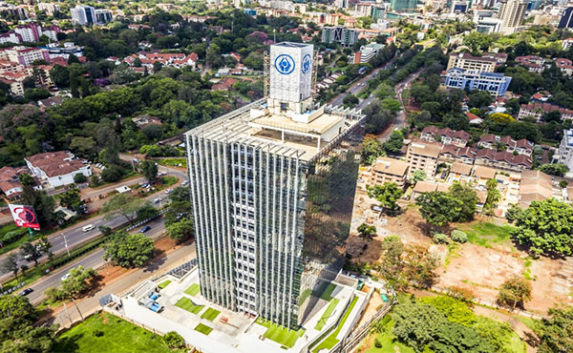

SANLAM TOWER

WAIYAKI WAY – WESTLANDS – NAIROBI

Location

Sanlam Tower is a prestigious grade A landmark building situated along Waiyaki Way in the affluent suburbs of Westlands Nairobi.

Structure
- Eighteen Storey tower commercial/office block on 0.353 of an acre
- 4No. basement levels parking
- 3No. podium parking levels
- Typical offices from 4th to 18th floor
- Total lettable office space of 158,408 sq ft
- 398 No. parking bays

Concept
Sanlam Tower is a professionally designed development consisting of executive offices strategically located within the heart of Nairobi’s affluent suburb of Westlands. It comprises of the three functional parts of a commercial building which are ground floor retail, basement and podium parking levels and fourteen (14) no. tower office space levels.

The form of the building has been achieved as a direct response to environmental and design brief considerations together with the importance of the site relative to it’s surrounding, coupled with desire to produce a clean, green building of high aesthetic value providing comfortable working environment.

Facilities
- Six (6) No. high speed lifts of 1000kg (13 persons) capacity each
- Three phase KPLC power connection
- Intelligent building management system guaranteeing safety & security
- 2No. 500 Kva Standby power back-up generators
- Ample water storage capacity of over to 100,000 litres and borehole water supply
- Occupation sensors lighting control, Infra-red sensor taps and rain water harvesting
- Common washrooms for each gender on each floor as well as for persons with disability
- Modern ‘piazza’ lobby with three-storey glass atrium bathed in natural lighting
- Fire fighting equipments of each floor
- Automatic water sprinkler system
- High performance curtain wall glazing system that reduces heat gain and glare while allowing plenty of natural light

Security
- 24 hour security guarding and monitoring
- 24 hour state of the art CCTV surveillance
- Smart card access system
- Security back-up response
- Security reception desk in expansive lobby

Occupancy
- The building is currently 42% occupied
- Monthly rental income is Kshs.20,240,800 assuming full occupancy

Price Guide
Kshs.2.8 billion (Two Billion Eight Hundred Million Kenya Shillings)

SELLING AGENT
LLOYD MASIKA LIMITED
REGISTERED VALUERS AND ESTATE AGENTS
Norfolk Towers – Kijabe Street CONTACT
P.O Box 45733 – 00100 – NAIROBI Justin Mwangi - 0721321 327
Tel: 2279000, 2215900, 2218112/3 Joyce Njogu - 0727141123
Mobile: 0728519443, 0733597050
Email: info@lloydmasika.co.ke
Website: www.lloydmasika.co.ke

