SALE PARTICULARS – FACT SHEET
PRIME LAND FOR SALE- SULTAN HAMUD
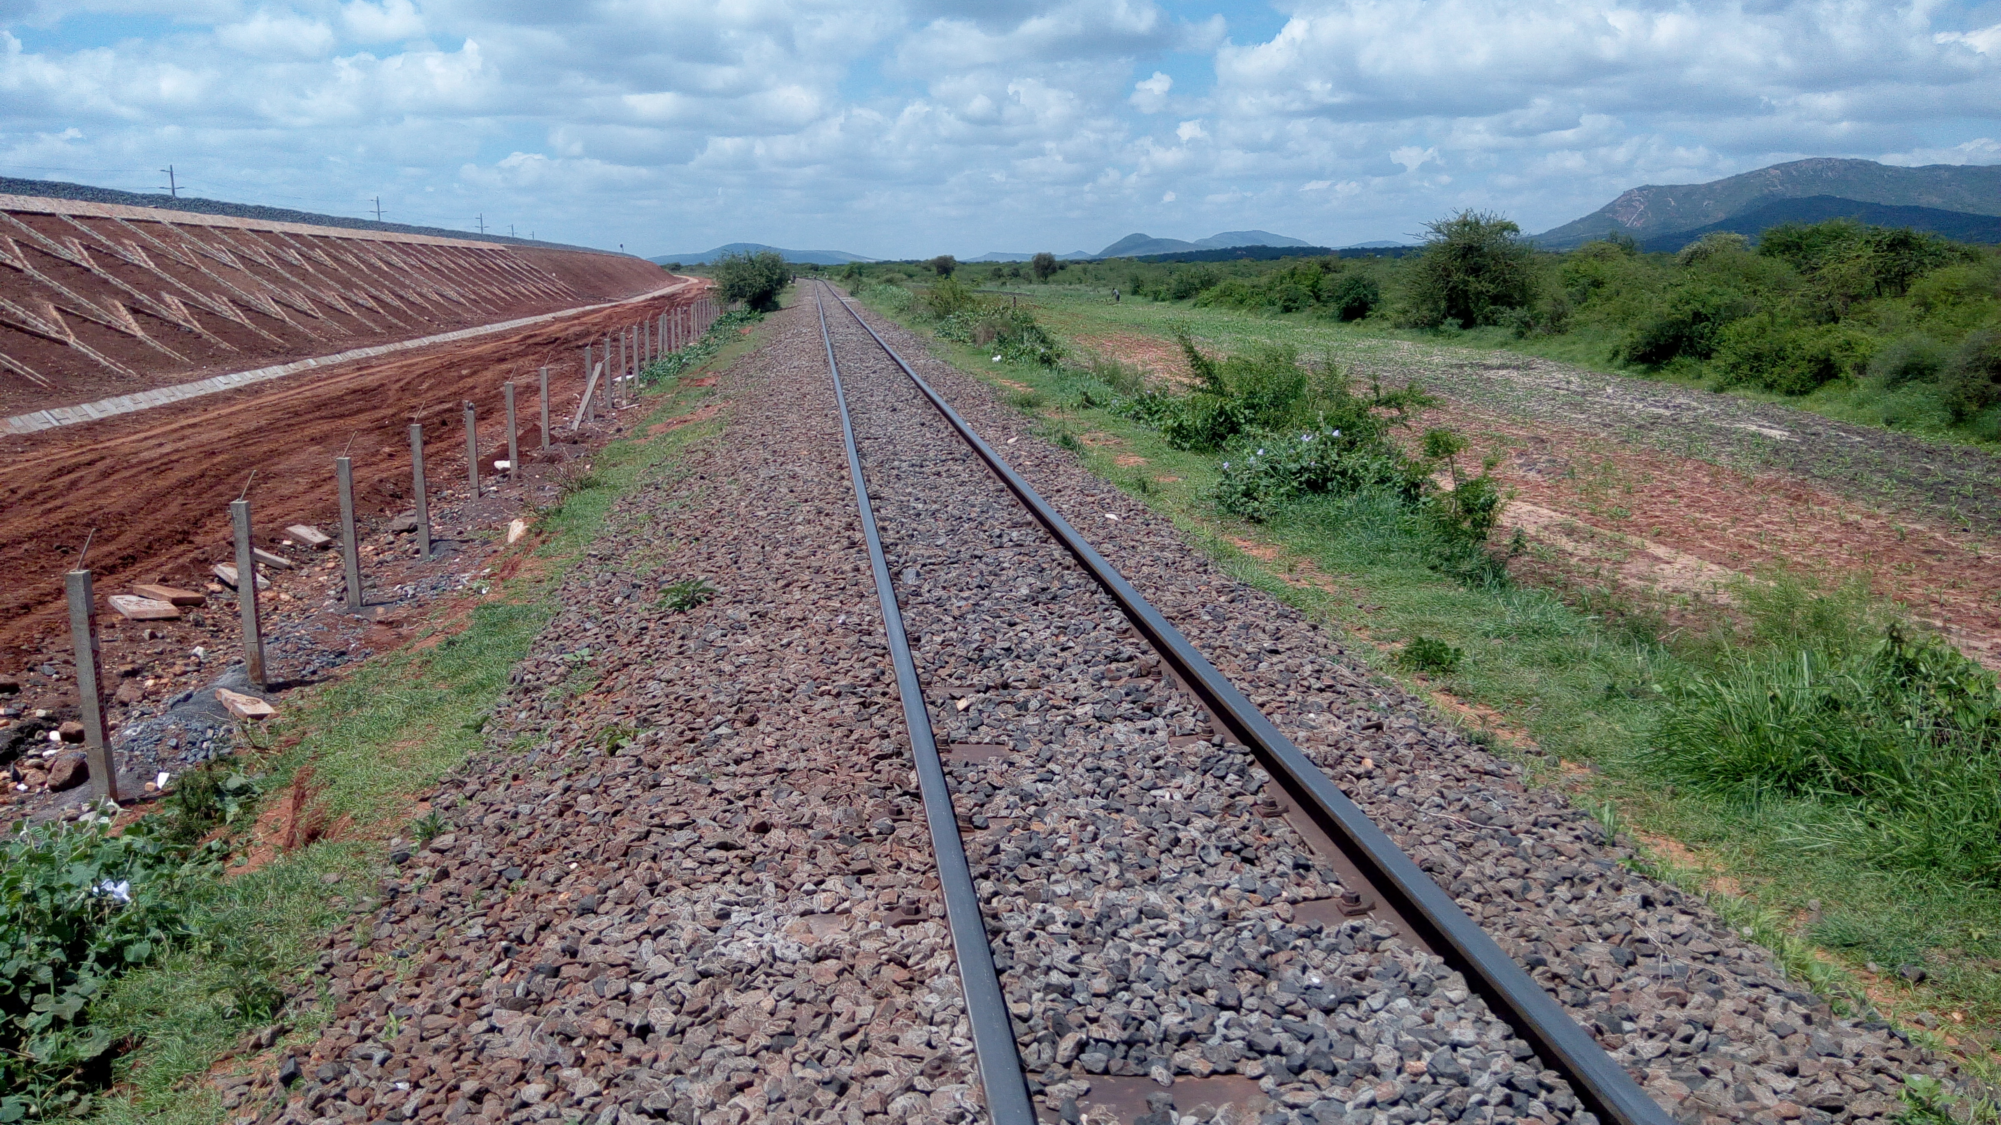
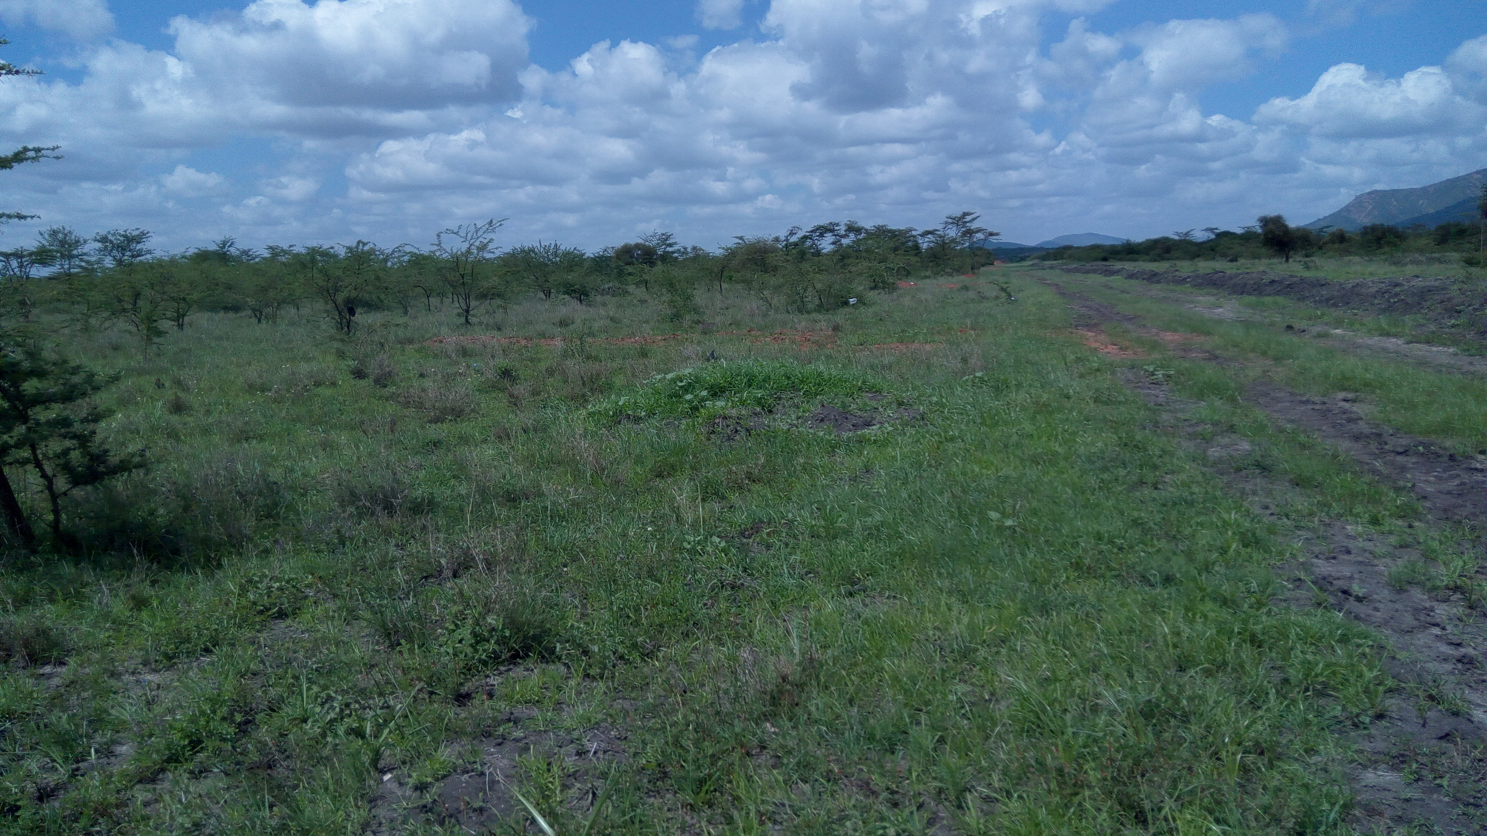

The subject land SGR Line to which the land Fronts
Location:
The land is situated along Mombasa Road, 2Km from Sultan Hamud town and fronts the Standard Gauge Railway.
The Land:
This is an irregular shaped, level, red soils land whose boundaries are part marked by the railway line and pipeline (Railway and Pipeline lines) and part open.
Title:  Leasehold title for a period of 999 years with effect from 1st August 1955. | Developments:  Vacant
Area:
The land measures 150 Acres approximately.
Services:
Electricity – Electricity is ready for connection to the property. There’s a power sub-station in Sultan Hamud Town.
Water-is piped from the Kilimanjaro Water project scheme.
Drainage- is to sewer is to septic tanks.
Nairobi – Mombasa Road is tar surfaced.
Commentary:
This is a prime agricultural/residential/commercial land located within Sultan Hamud and strategically placed between the Pipeline and SGR railway lines.
Demand for similar parcels for development and farming purpose within the area is currently strong.
Price Guide:
Entire parcel: Kshs 1,200,000.00 per acre

